1. **Docker registry or repository is used to upload your images locally. For this, first you have to create container from default Registry image.**

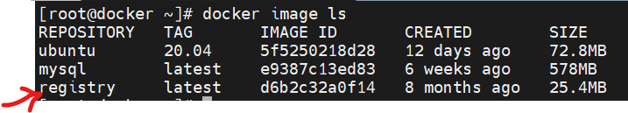

1. **You can define the different volume to store these image data. i.e AWS S3 bucket, google or Alibaba storages.**

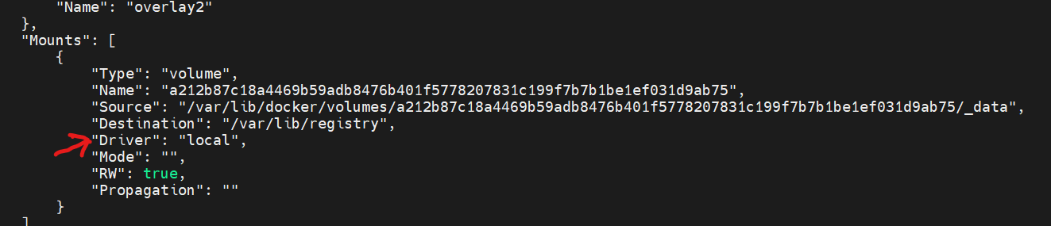

1. **You need to change the tag of image which you want to push in local repository because docker default check for public repository.**



1. **To push image,**

**#docker image push 127.0.0.1:5000/ubuntu:20.04**



1. **Docker default supports secure connection(https) except 127.0.0.0/8 CIDR. Hence you are able to push image in 127.0.0.1.**
2. **You can create secure local docker repository. Check steps online.**
3. **You can enable use authentication on repository. So that, others can’t push or pull images. Check steps online.**